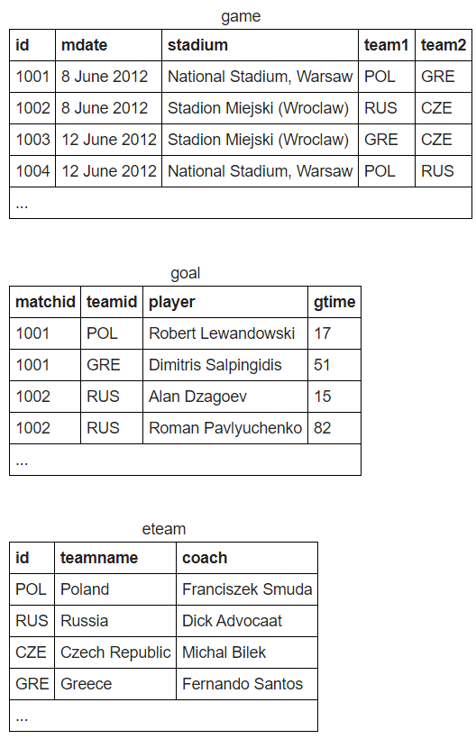

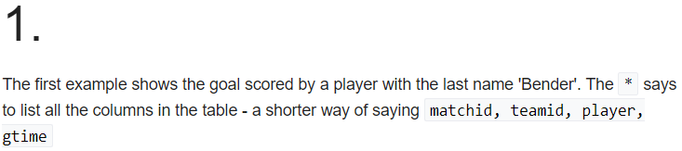

**SELECT matchid,player FROM goal WHERE teamid LIKE 'GER'**

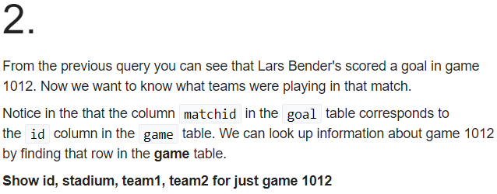

**SELECT id,stadium,team1,team2 FROM game WHERE id LIKE '1012'**

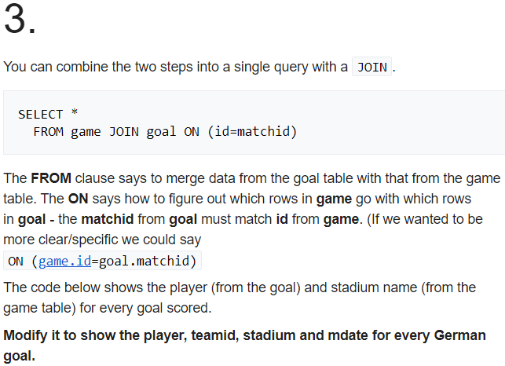

**SELECT player,teamid,stadium,mdate FROM goal JOIN game ON (goal.matchid=**[**game.id**](http://game.id/)**) WHERE goal.teamid LIKE 'GER'**

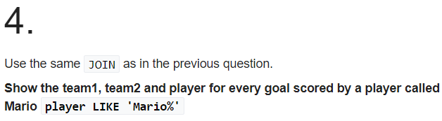

**SELECT team1,team2,player FROM goal JOIN game ON (goal.matchid=**[**game.id**](http://game.id/)**) WHERE player LIKE 'Mario%'**

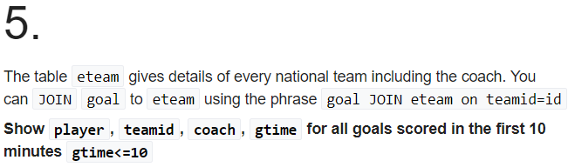

**SELECT player, teamid, coach,gtime FROM goal JOIN eteam ON (goal.teamid=**[**eteam.id**](http://eteam.id/)**) WHERE gtime<=10**

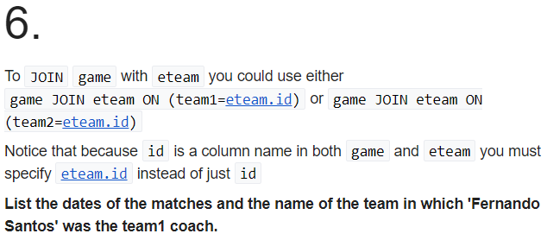

**SELECT mdate,teamname FROM game JOIN eteam ON (game.team1=**[**eteam.id**](http://eteam.id/)**) WHERE coach LIKE 'Fernando Santos'**

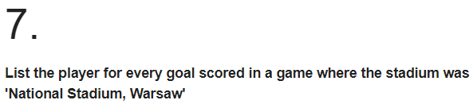

**SELECT go.player FROM game ga JOIN goal go ON (id=matchid) WHERE ga.stadium = 'National Stadium, Warsaw';**

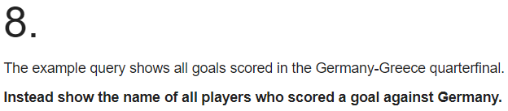

**SELECT DISTINCT player FROM goal JOIN game ON matchid = id WHERE (teamid = team1 AND team2 = 'GER') OR (teamid = team2 AND team1 = 'GER');**

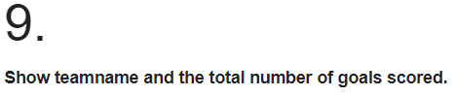

**SELECT teamname, COUNT(teamid) FROM eteam JOIN goal ON id=teamid GROUP BY teamname;**

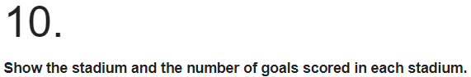

**SELECT stadium, COUNT(teamid) FROM game JOIN goal ON id=matchid GROUP BY stadium;**

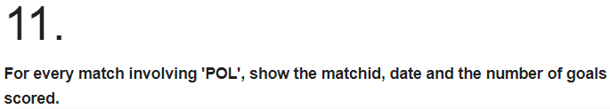

**SELECT matchid, mdate, COUNT(player) AS goals FROM game JOIN goal ON (matchid=id AND (team1 = 'POL' OR team2 = 'POL')) GROUP BY matchid, mdate**

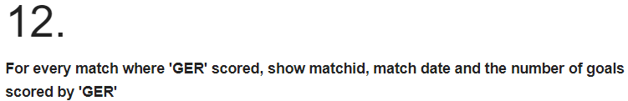

**SELECT id, mdate, COUNT(player) FROM game JOIN goal ON (id=matchid AND (team1 = 'GER' OR team2 = 'GER') AND teamid='GER') GROUP BY id, mdate**

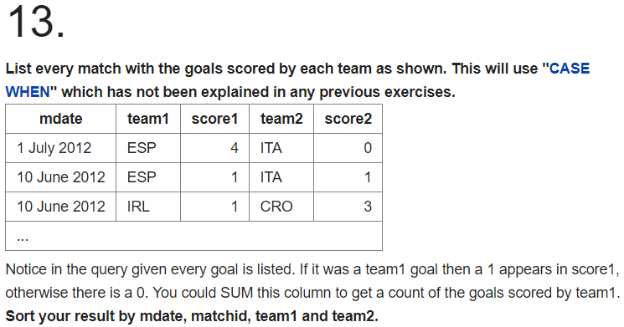

**SELECT mdate, team1, SUM(CASE WHEN teamid = team1 THEN 1 ELSE 0 END) AS score1, team2, SUM(CASE WHEN teamid = team2 THEN 1 ELSE 0 END) AS score2 FROM game LEFT JOIN goal ON (id = matchid) GROUP BY mdate,team1,team2 ORDER BY mdate, matchid, team1, team2**